-- ============================================================
-- LIBRARY_SELECT_QUESTIONS.SQL
-- Practice Questions: SELECT statements only
-- * SELECT, WHERE, ORDER BY, DISTINCT, aggregate functions,
-- GROUP BY, HAVING, date functions, string functions,
-- numeric functions and CASE may be used where appropriate.
-- ============================================================

-- 1. Display the member ID, full name, member type and city of all ACTIVE
-- members, arranged first by member type and then alphabetically by name.

SQL> select member_id,full_name,member_type,city from member where status ='ACTIVE' order by member_type , full_name ;

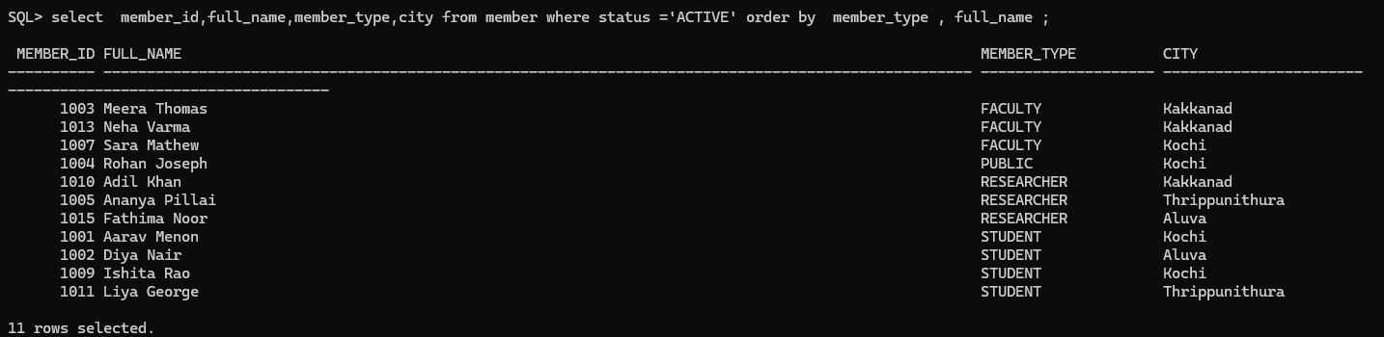

-- 2. List the members whose outstanding amount is between 50 and 300,
-- inclusive. Show member ID, name, outstanding amount and status in
-- descending order of outstanding amount.

SQL> SELECT member_id,full_name ,outstanding_amt from member where outstanding_amt between 50 and 300 order by outstanding_amt desc;
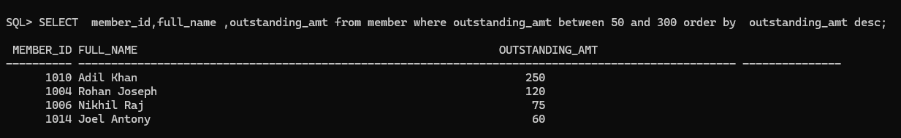

-- 3. Display all members who are either STUDENT or RESEARCHER and whose
-- maximum borrowing limit is at least 4 books. Sort by max_books descending.

SQL> select * from member where (member_type ='STUDENT' or member_type='RESEARCHER' ) AND MAX_BOOKS >=4 ORDER BY MAX_BOOKS DESC;

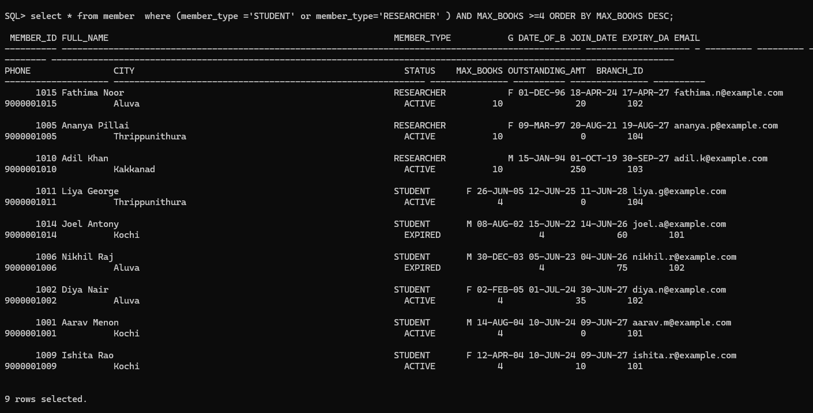

-- 4. Display member name, join date and the number of complete years they have
-- been members as of SYSDATE. Show the longest-standing members first.
-- Hint: MONTHS_BETWEEN can be useful.

-- 5. Display the names and email addresses of members whose name contains the
-- letter 'a' anywhere, ignoring case, and whose account is ACTIVE.

SQL> SELECT full_name, email from member where full_name like '%a%' and status ='ACTIVE';
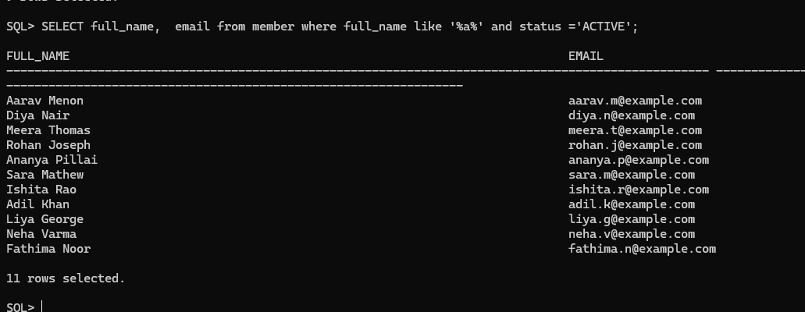

-- 6. Produce a member-status summary showing each status, the number of members
-- in that status and the average outstanding amount for that status.
-- Round the average to two decimal places.

SQL> SELECT STATUS,
2 COUNT(*),
3 AVG(OUTSTANDING_AMT),
4 ROUND(AVG(OUTSTANDING_AMT), 2)
5 FROM MEMBER
6 GROUP BY STATUS;

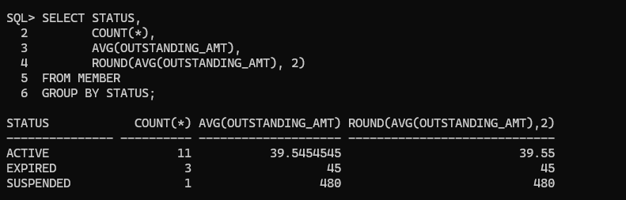

-- 7. Display cities having at least 2 registered members. Show the city,
-- number of members and total outstanding amount for that city.
-- Arrange by number of members descending.

SQL> SELECT CITY,COUNT(*),SUM(OUTSTANDING_AMT) FROM MEMBER GROUP BY CITY ORDER BY COUNT(*) DESC;
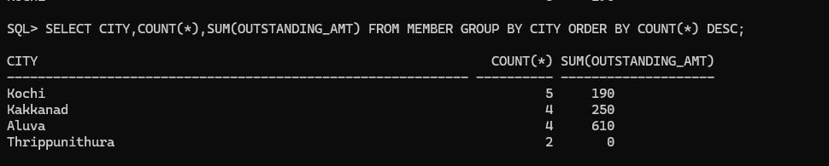

-- 8. Display staff name, role, shift and salary for staff earning from
-- 32,000 to 56,000 inclusive, excluding GENERAL shift staff.
-- Sort from highest to lowest salary.

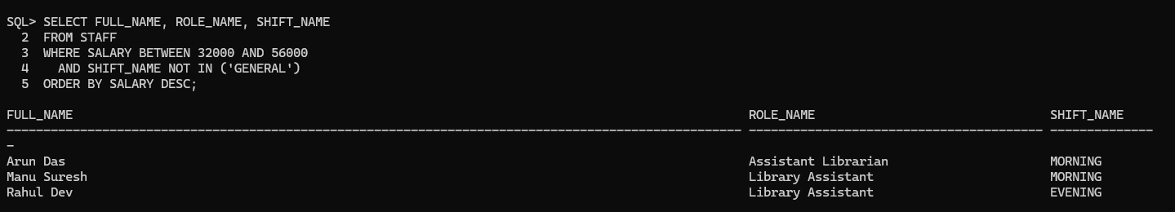

-- 9. For each shift in the STAFF table, display the number of employees,
-- minimum salary, maximum salary and average salary.
-- Round average salary to two decimal places.

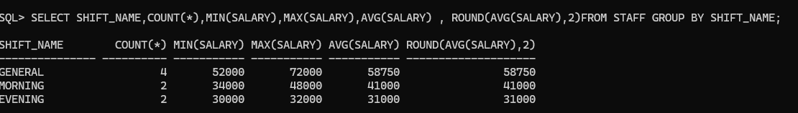

-- 10. Display staff members hired before 1 January 2020 whose salary is above
-- 50,000. Show staff ID, name, hire date and salary.

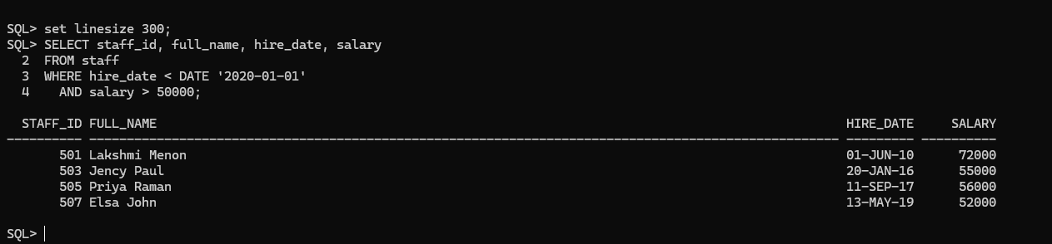

-- 11. Display each publisher's name, country and age in years in 2026
-- (2026 - established_year). Show the oldest publishers first

-- 12. Display countries that have at least two publishers in the database.
-- Show country and number of publishers.

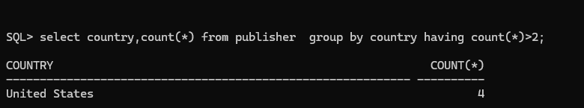

-- 13. Display authors born before 1960 who have received at least 2 awards.
-- Show author name, nationality, birth year and awards count, ordered by
-- awards count descending and then birth year ascending.

SQL> select author_name,nationality,birth_year ,awards_count from author where birth_year <1960 and awards_count >=2 order by awards_count desc, birth_year ;
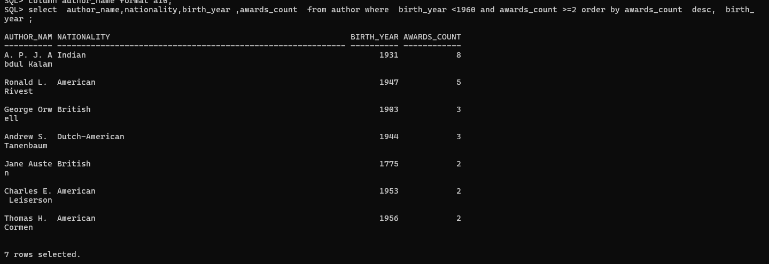

-- 14. For each nationality in AUTHOR, display the number of authors and the
-- total number of awards received. Include only nationalities whose total
-- awards count is at least 5.

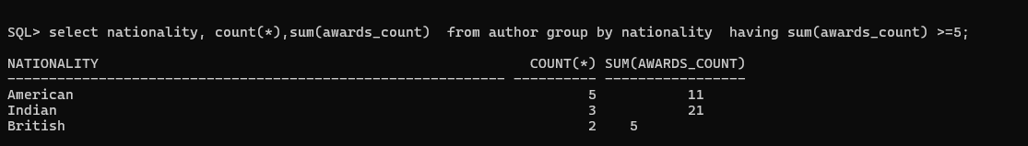

-- 15. Display book ID, title, category, publication year and price for books
-- published from 2014 onward with price above 700. Sort by price descending.

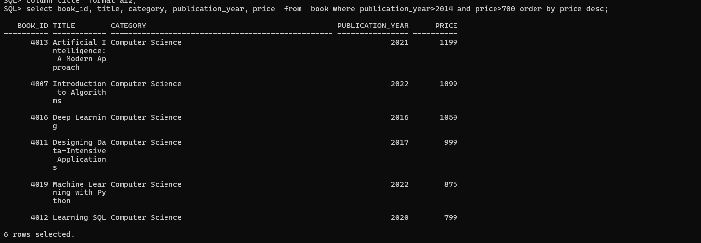

-- 16. Display books whose title contains either the word 'Data' or the word
-- 'Learning', ignoring case. Show title, category, year, pages and rating.

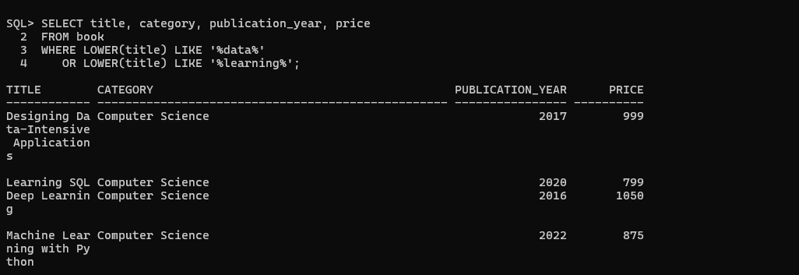

-- 17. Display books with more than 500 pages and a rating of at least 4.5.
-- Add a computed column named PRICE_PER_100_PAGES showing the approximate
-- price per 100 pages, rounded to two decimals.

-- 18. Display the category-wise number of books, average price and average
-- rating. Show only categories containing at least 2 books.
-- Round averages to two decimals.

-- 19. Display publication years in which at least 2 books in the BOOK table
-- were published. Show the year, number of books and average price.

-- 20. Categorise every book using a CASE expression:
-- price < 400 -> 'BUDGET'
-- price between 400-799 -> 'STANDARD'
-- price >= 800 -> 'PREMIUM'
-- Display book title, price and the computed price category.
-- Sort by price descending.

-- 21. Display all physical copies purchased during 2024 or 2025.
-- Show copy ID, accession number, purchase date, purchase price,
-- condition and availability status.

-- 22. Display the number of book copies in each availability status.
-- Show only statuses having at least 2 copies, ordered by count descending.

-- 23. Display each condition status from BOOK_COPY together with the number of
-- copies and average purchase price. Round the average price to two decimals.

-- 24. Display currently unreturned loans (return_date IS NULL) that were issued
-- before 20 August 2026. Show loan ID, member ID, issue date, due date,
-- renewal count and loan status.

-- 25. For every loan, display loan ID, issue date, due date, return date and a
-- calculated column DAYS_ALLOWED equal to due_date - issue_date.
-- Sort by DAYS_ALLOWED descending and then loan ID.

-- 26. Display a summary of loans by loan_status showing the number of loans,
-- average renewal count and earliest issue date for each status.

-- 27. Display returned loans where the book was returned after the due date.
-- Show loan ID, member ID, due date, return date and the number of days late
-- calculated as return_date - due_date.

-- 28. Display reservations made during August 2026 that are still WAITING.
-- Show reservation ID, member ID, book ID, reservation date, expiry date
-- and priority number. Arrange by priority number and then reservation date.

-- 29. Display reservation-status counts, but include only statuses occurring
-- at least 2 times. Sort from most frequent to least frequent.

-- 30. Display fines that are not fully settled, i.e. payment_status is UNPAID
-- or PARTIAL. Show fine ID, member ID, reason, amount, amount paid and a
-- computed BALANCE_AMOUNT = amount - amount_paid. Sort by balance descending.

-- 31. From FINE, produce a reason-wise summary containing:
-- reason, number of fines, total amount charged, total amount paid and
-- total balance outstanding. Show reasons with total charged >= 100.

-- 32. Display the top-level borrowing pattern in LOAN by month of issue.
-- Show month as YYYY-MM, number of loans and average renewal count,
-- ordered chronologically.
-- Hint: TO_CHAR(issue_date, 'YYYY-MM').

-- 33. From MEMBER, display ACTIVE members whose membership expires within the
-- next 365 days from SYSDATE. Show name, member type, expiry date and the
-- approximate number of days remaining.

-- ============================================================
-- END OF QUESTION SET
-- ============================================================

